**Module 8: **Final Project**

Rafe Mohammed Abdul

Masters in Information Technology, Arizona State University

IFT458&544: Middleware Prog & Database Sec

Prof: Dinesh Sthapit

Due: December 01, 2023

**Table of Contents**

Abstract 3

Introduction 4

Overview: 4

Problem Statement: 4

Scope and Limitations: 4

Project Design 6

Architecture 6

Flow Charts: 9

Pseudocode or Code Snippets 12

API Specifications 19

Screenshots 25

Learning Outcomes 35

Constructive Feedback 36

References 38

Appendices 40

Abstract

The project endeavors to establish a resilient book exchange platform, cultivating a vibrant community of readers dedicated to sharing and exchanging their cherished books. Characterized by a user-friendly web interface, the platform serves as a catalyst for book discovery, forging connections among bibliophiles, and ensuring frictionless book exchanges. The chosen technology stack comprises Node.js and Express.js for the backend, MongoDB as the database, and EJS for dynamic views. This strategic selection is underpinned by the paramount need for a platform that is not only scalable but also responsive to the evolving demands of a diverse user base.

At its core, the platform seeks to redefine the way readers engage with literature by providing an immersive and interactive space. Users can seamlessly explore an extensive collection of books, fostering a sense of shared enthusiasm for diverse literary genres. The utilization of Node.js and Express.js ensures efficient handling of real-time interactions, making the platform conducive to dynamic exchanges and updates. MongoDB, as the backend database, offers the flexibility needed to manage varied data types associated with books, users, and interactions. The incorporation of EJS for dynamic views further enhances the user experience, delivering personalized and real-time content.

In essence, this project not only aspires to create a practical and efficient book exchange platform but also aims to cultivate a thriving community centered around a collective love for reading. Through thoughtful technology choices, the platform is poised to become a scalable, responsive, and indispensable hub for bibliophiles to connect, share, and embark on literary journeys together.

# Introduction

## Overview:

The book exchange platform introduces a transformative space where users can seamlessly explore, connect, and exchange books, fostering a sense of collaboration within the reading community. This innovative online environment transcends the conventional boundaries of reading, providing a dynamic and interactive platform for bibliophiles to engage in the shared experience of discovering, sharing, and exchanging their favorite books.

## Problem Statement:

The genesis of this project arises from the recognition of a prevalent issue in the reading community—the absence of efficient platforms for book enthusiasts to connect and exchange books. Traditional avenues often lack the technological sophistication and user-centric features needed to facilitate meaningful interactions among readers. This deficiency inhibits the potential for a more interconnected and collaborative reading experience.

## Scope and Limitations:

The primary scope of the book exchange platform is to empower users to engage in book exchanges, creating a vibrant and interconnected reading community. Users can explore diverse literary works, connect with like-minded individuals, and facilitate seamless book exchanges. However, it's crucial to acknowledge certain limitations. While the platform prioritizes book exchanges, challenges may emerge in sustaining consistent user engagement. Factors such as varying user preferences, time constraints, or external commitments may impact the frequency and depth of interactions. It is essential to recognize and address these challenges proactively to enhance the overall user experience and ensure the platform's long-term viability.

In essence, the platform aspires to bridge the gap in the literary community, offering a dynamic solution to book enthusiasts while being mindful of potential challenges associated with user engagement. By carving a niche in the realm of collaborative reading, the platform endeavors to redefine how individuals connect over their shared love for books.

**Node.js and Express.js:**

Node.js is selected for its event-driven, non-blocking I/O model, making it exceptionally efficient for handling asynchronous operations. This is particularly advantageous for a book exchange platform where real-time interactions and data updates are integral. Express.js, as a minimal and flexible Node.js web application framework, complements this by providing a streamlined and organized structure for handling HTTP requests and views. The use of these technologies ensures that the platform can handle concurrent user interactions, such as book searches, user registrations, and real-time updates, with optimal performance and responsiveness.

**MongoDB:**

The choice of MongoDB as the backend database is rooted in its NoSQL nature, offering flexibility in handling unstructured data. In the context of a book exchange platform, where diverse information about books, users, and interactions needs to be stored and retrieved, MongoDB excels. Its schema-less design allows for easy adaptation to evolving data structures, facilitating efficient storage and retrieval of information. Additionally, MongoDB's support for horizontal scaling ensures the platform's scalability as the user base grows, accommodating the dynamic nature of book-related data.

**EJS (Embedded JavaScript):**

EJS is employed for dynamic views, playing a pivotal role in creating a responsive and engaging user interface. By embedding JavaScript code directly into HTML markup, EJS allows for the dynamic generation of HTML content on the server side. This is crucial for serving personalized and real-time content to users, enhancing their experience on the platform. For instance, in the provided code snippets, EJS is used to dynamically display the user's IP address, current date and time, and personalized messages upon successful authorization. This dynamic content ensures that users receive up-to-date information and a tailored experience, contributing to the overall user satisfaction and engagement on the platform.

# Project Design

## Architecture

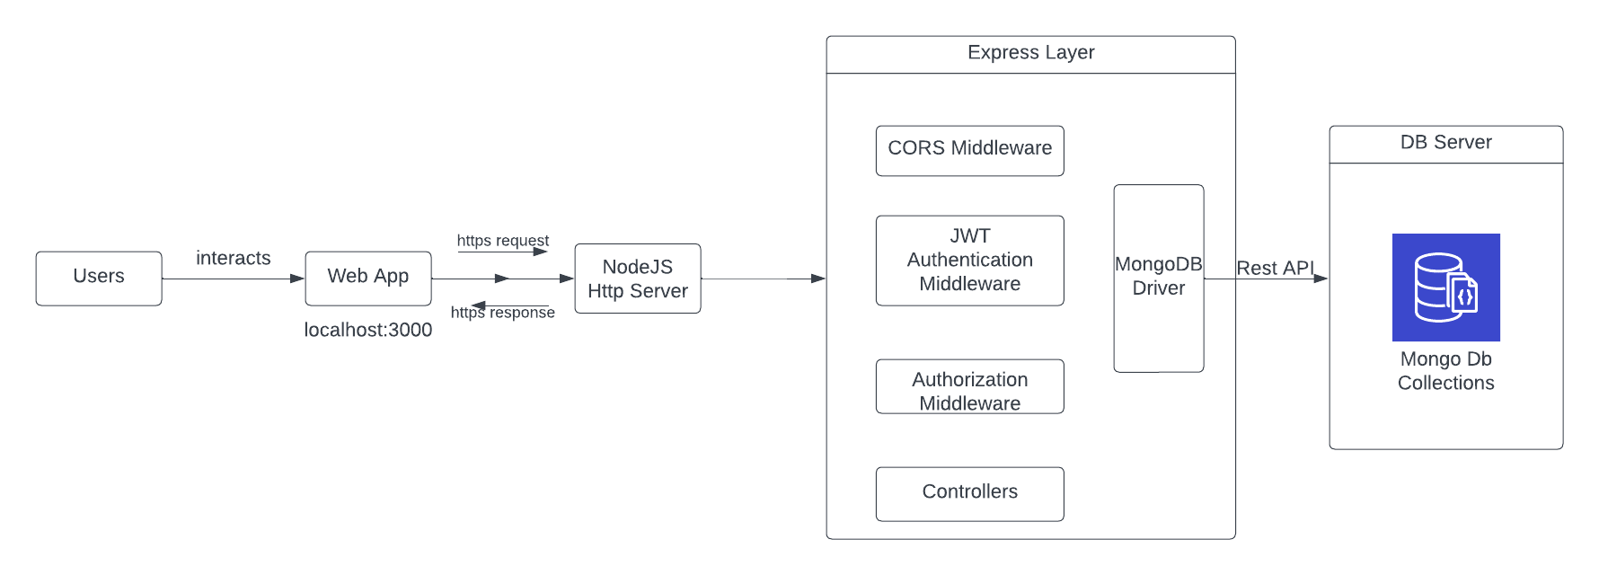

**Users interact with the Web App:**

Users engage with the web application through the user interface provided by the Web App. This interaction involves actions like browsing books, registering, logging in, and initiating book exchange requests.

**Web App makes HTTP requests to Node.js server:**

The Web App communicates with the backend server (Node.js) by sending HTTPS requests. These requests contain information about user actions, such as requesting book details, initiating a book exchange, or authenticating a user.

**Node.js server with Express layer:**

The Node.js server utilizes the Express.js framework, which acts as the backend infrastructure for handling incoming requests and managing the application's business logic.

**Express Layer Components:**

**CORS Middleware:** Handles Cross-Origin Resource Sharing, allowing the web application to make requests from a different domain.

**JWT Authentication Middleware:** Manages user authentication using JSON Web Tokens (JWT), verifying the identity of users during secure interactions.

**Authorization Middleware:** Ensures that users have the necessary permissions to perform certain actions, providing an additional layer of security.

**Controllers:** Handle the application's logic based on the received requests, orchestrating interactions with the database and other services.

**MongoDB Driver:** Interacts with the MongoDB database to perform CRUD (Create, Read, Update, Delete) operations based on the application's requirements.

**REST API (Express Controllers):**

The Express controllers interpret the incoming HTTP requests, execute the corresponding logic, and prepare the data for a response.

**MongoDB Database Server:**

The MongoDB database stores and retrieves data related to users, books, and exchanges. It responds to queries made by the Express controllers, ensuring persistent data storage.

**HTTP Responses back to the Web App:**

Once the Express controllers have processed the requests and obtained the necessary data from the MongoDB database, they send HTTP responses back to the Web App. These responses may include requested book details, authentication tokens, or confirmation messages.

**Web App processes HTTP Responses:**

The Web App processes the received HTTP responses and updates the user interface accordingly. For example, it may display book details, confirm successful user authentication, or notify the user about the outcome of a book exchange request.

This flow ensures a seamless interaction between users and the book exchange platform, with the Node.js server and Express layer managing the backend operations and MongoDB serving as the persistent data store. The use of middleware and controllers in Express enhances the security and modularity of the application.

## Flow Charts:

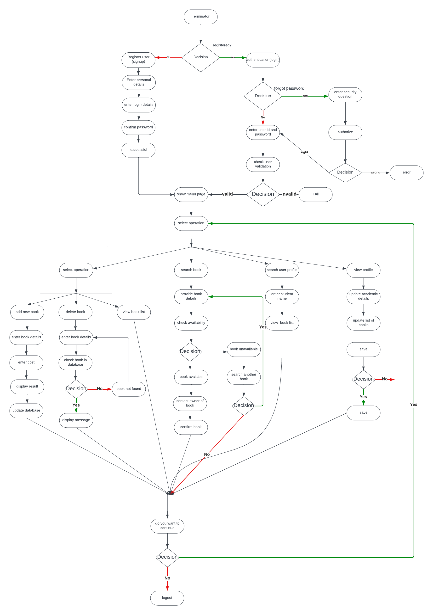

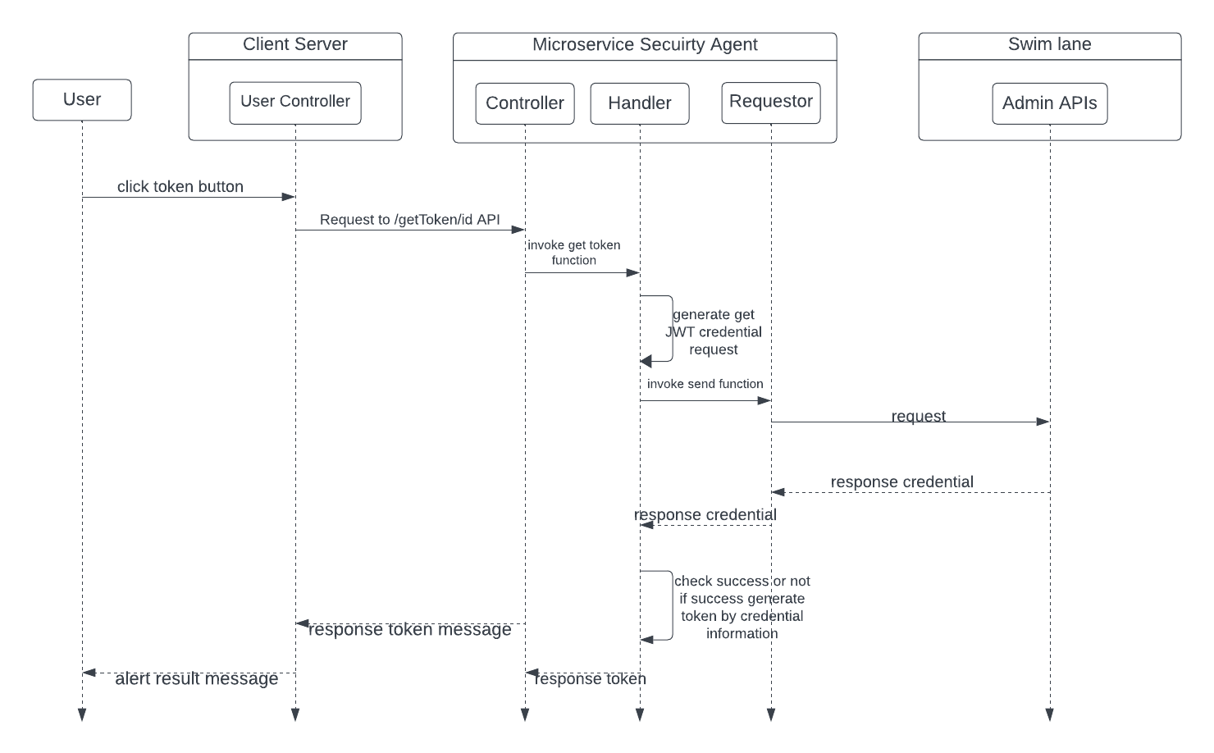

**MVC architecture**

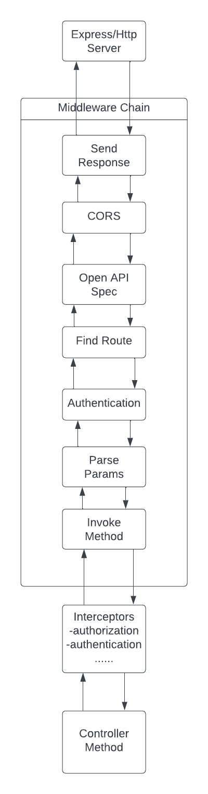

## Pseudocode or Code Snippets

**getBooks**

I have also added a filter the book by Title, Author, Exchange type, Status and Rating.

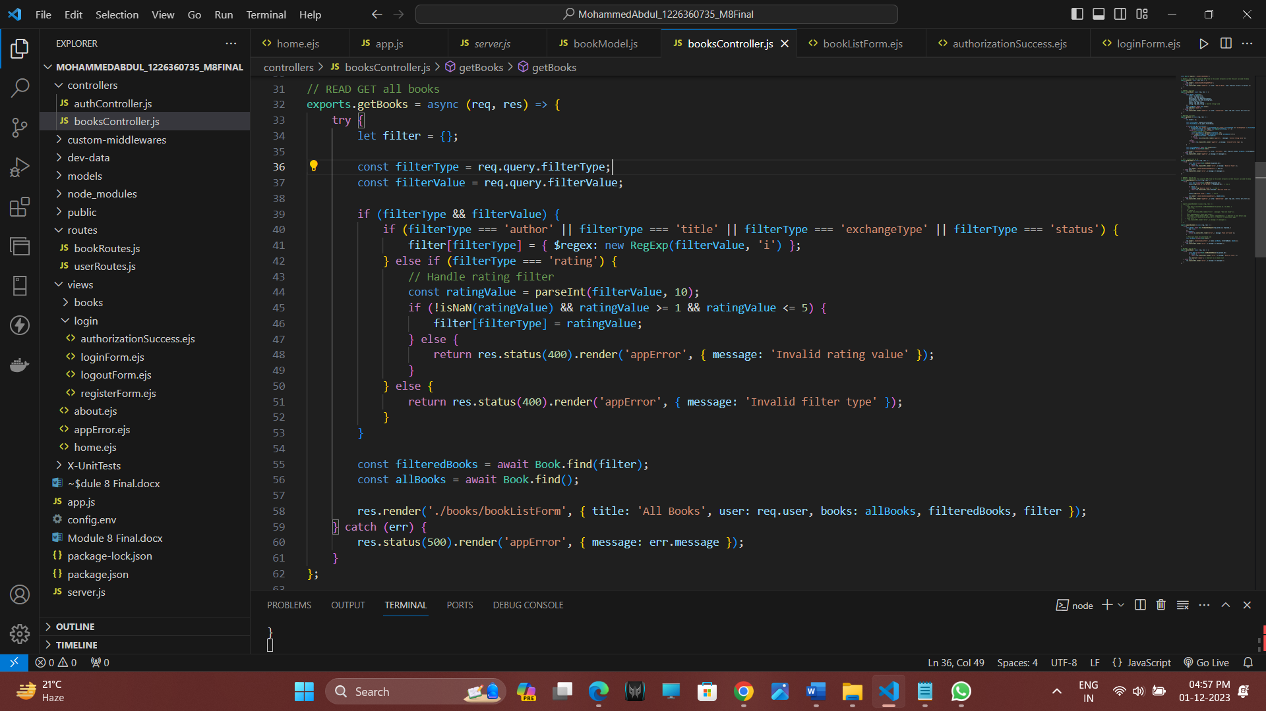exports.getBooks = async (req, res) => {

try {

// Initialize an empty filter object

let filter = {};

// Extract filterType and filterValue from query parameters

const filterType = req.query.filterType;

const filterValue = req.query.filterValue;

// Check if both filterType and filterValue are provided

if (filterType && filterValue) {

// Handle different filter types

if (filterType === 'author' || filterType === 'title' || filterType === 'exchangeType' || filterType === 'status') {

// For text-based filters, use case-insensitive regex matching

filter[filterType] = { $regex: new RegExp(filterValue, 'i') };

} else if (filterType === 'rating') {

// Handle rating filter

const ratingValue = parseInt(filterValue, 10);

// Check if the ratingValue is a valid integer between 1 and 5

if (!isNaN(ratingValue) && ratingValue >= 1 && ratingValue <= 5) {

filter[filterType] = ratingValue;

} else {

// If invalid, return a 400 Bad Request response with an error message

return res.status(400).render('appError', { message: 'Invalid rating value' });

}

} else {

// If an unsupported filter type is provided, return a 400 Bad Request response

return res.status(400).render('appError', { message: 'Invalid filter type' });

}

}

// Retrieve books from the database based on the constructed filter

const filteredBooks = await Book.find(filter);

// Retrieve all books (without filtering) for display purposes

const allBooks = await Book.find();

// Render the book list page with the retrieved books and filter information

res.render('./books/bookListForm', { title: 'All Books', user: req.user, books: allBooks, filteredBooks, filter });

} catch (err) {

// Handle server errors by rendering an error page

res.status(500).render('appError', { message: err.message });

}

};

**Explanation**

**Filter Construction:**

The function initializes an empty filter object that will be used to construct the query for retrieving books.

**Filter Extraction:**

It extracts filterType and filterValue from the query parameters of the incoming request.

**Filter Handling:**

Based on the filterType, the function constructs the appropriate filter condition for MongoDB. It supports text-based filters (author, title, exchangeType, status) using case-insensitive regex matching. For the 'rating' filter, it validates the provided rating value and includes it in the filter.

**Database Query:**

It uses the constructed filter to query the MongoDB database for books that match the specified criteria.

**Rendering the View:**

The function renders a view (assumed to be 'bookListForm') with the retrieved books (allBooks and filteredBooks) and additional information such as the applied filter. This view is likely used to display a list of books.

**Error Handling:**

If any errors occur during the process, the function catches them and renders an error page (appError) with the error message.

This code handles the retrieval of books based on specified filters, validates input, and renders a view with the filtered books for display in a web application.  
**Adding a book**

I have added rating the book as a new feature.

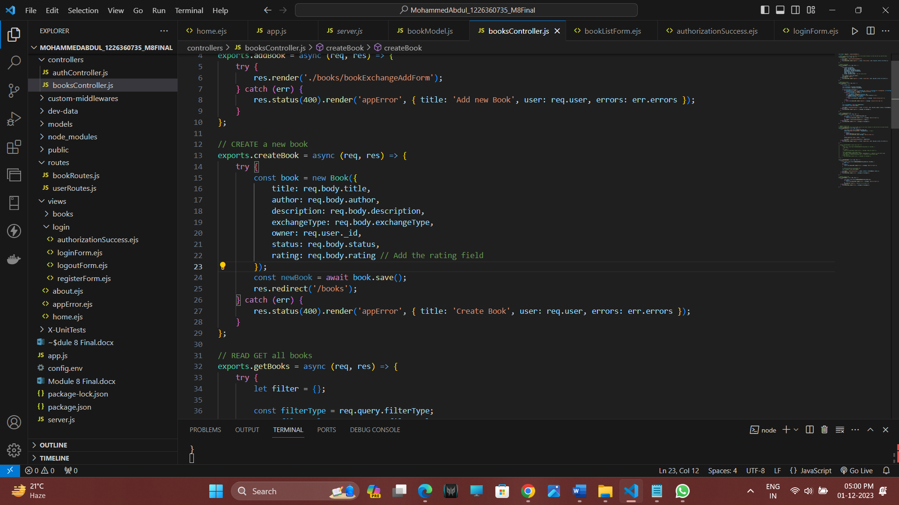// CREATE a new book

exports.createBook = async (req, res) => {

try {

// Create a new Book instance with data from the request body

const book = new Book({

title: req.body.title,

author: req.body.author,

description: req.body.description,

exchangeType: req.body.exchangeType,

owner: req.user._id, // Set the owner of the book to the current user's ID

status: req.body.status,

rating: req.body.rating // Add the rating field

});

// Save the new book to the database

const newBook = await book.save();

// Redirect the user to the '/books' route after successfully creating the book

res.redirect('/books');

} catch (err) {

// If an error occurs during book creation, handle the error

// Render an error page ('appError') with the error details

res.status(400).render('appError', { title: 'Create Book', user: req.user, errors: err.errors });

}

};

**Explanation  
Request Body:**

The function expects the book information to be sent in the request body (e.g., through a form submission). The information includes the book's title, author, description, exchangeType, status, and rating.

**Book Instance Creation:**

It creates a new instance of the Book model using the Mongoose ODM. The fields of the book instance are populated with data from the request body.

**Owner Assignment:**

The owner field of the book is set to the _id of the current user. This assumes that user authentication is implemented, and req.user contains information about the authenticated user.

**Database Save:**

The new book instance is saved to the MongoDB database using the save method, which is an asynchronous operation.

**Redirect:**

After successfully creating the book, the user is redirected to the '/books' route. This is a common practice to show the updated list of books, including the newly created one.

**Error Handling:**

If an error occurs during the creation of the book (e.g., validation errors), the function catches the error. It then renders an error page ('appError') with details about the error, including any validation errors.

## API Specifications

**Login**

**Login**POST http://localhost:4000/users/login

Content-Type: application/json

{

    "email":"rmoham2@asu.edu",

    "password":"rafe@asu"

}

Successfully Logged in

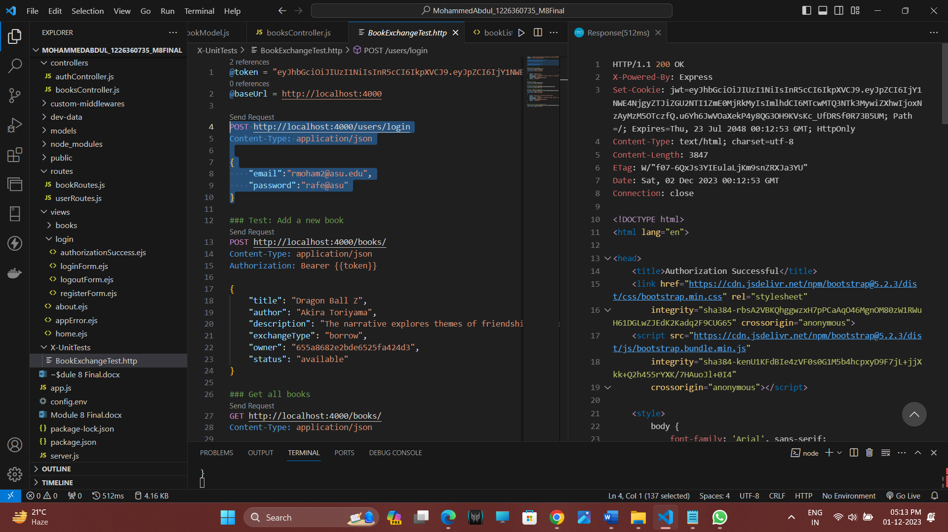

### Test: Add a new book

POST http://localhost:4000/books/

Content-Type: application/json

Authorization: Bearer {{token}}

{

    "title": "The Great Gatsby",

    "author": "F. Scott Fitzgerald",

    "description": "The Great Gatsby is a classic novel that explores themes of decadence, idealism, and the American Dream during the Roaring Twenties. Set in the summer of 1922, the story unfolds through the eyes of Nick Carraway, a Yale graduate and veteran of World War I. The narrative delves into the lives of Jay Gatsby, Nick's mysterious millionaire neighbor, and Daisy Buchanan, Nick's cousin and Gatsby's unrequited love.",

    "exchangeType": "trade",

    "owner": "655a8682e2bde6525fa424d3",

    "status": "available",

    "rating": "4"

}

**Endpoint:** /books (Adding books)

**HTTP Method:** POST

**Request:** Book Details

Example:

**Response:** Confirmation message

Added a book

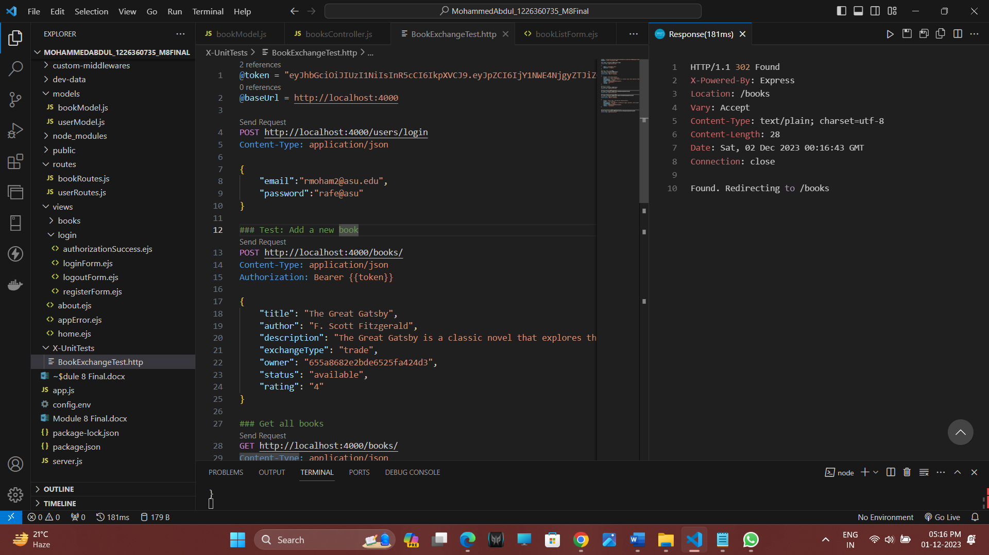

### Get all books

GET http://localhost:4000/books/

Content-Type: application/json

**Endpoint:** /books (handled operations related to book listings)

**HTTP Method:** GET

**Request:** None

**Response:** List of available books

Get all books

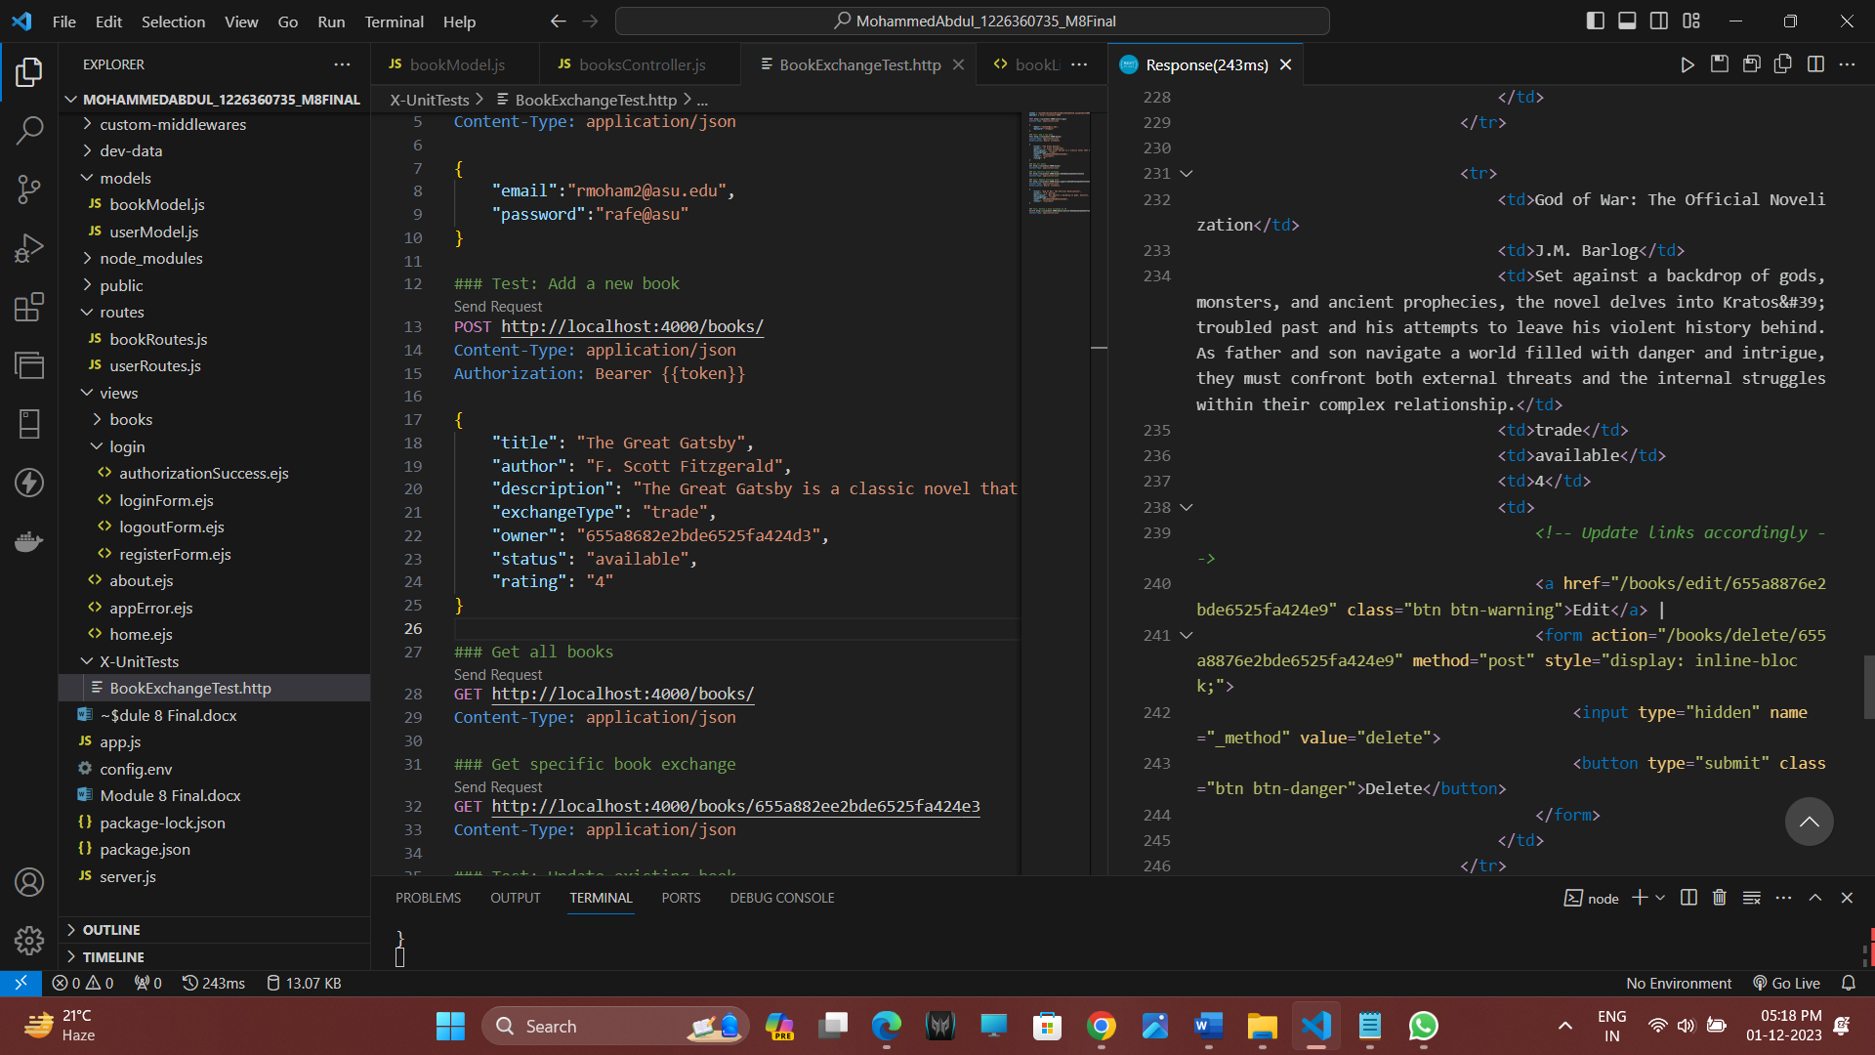

### Get specific book exchange

GET http://localhost:4000/books/655a882ee2bde6525fa424e3

Content-Type: application/json

**Endpoint:** /books/{id} (retrieves book by id)

**HTTP Method:** GET

**Request:** None

**Response:** Details of a specific book

Retrieved a book

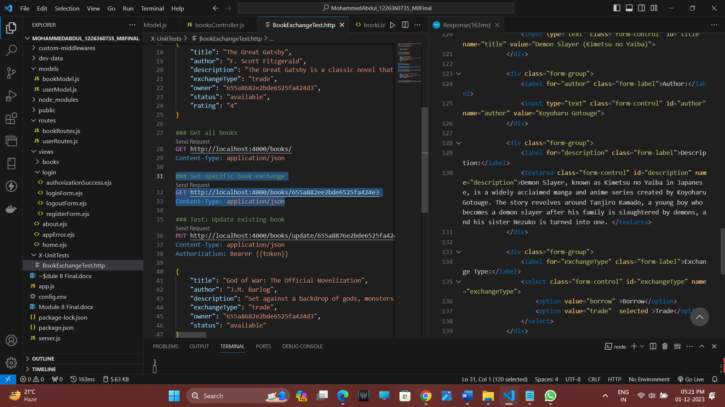

### Test: Update existing book

PUT http://localhost:4000/books/update/655a8876e2bde6525fa424e9

Content-Type: application/json

Authorization: Bearer {{token}}

{

    "title": "God of War 4: The Official Novelization",

    "author": "J.M. Barlog",

    "description": "Set against a backdrop of gods, monsters, and ancient prophecies, the novel delves into Kratos' troubled past and his attempts to leave his violent history behind. As father and son navigate a world filled with danger and intrigue, they must confront both external threats and the internal struggles within their complex relationship.",

    "exchangeType": "trade",

    "owner": "655a8682e2bde6525fa424d3",

    "status": "available",

    "rating":"5"

}

**Endpoint:** /books/{id} (Updating the book details)

**HTTP Method:** PUT

**Request:** Updated book details

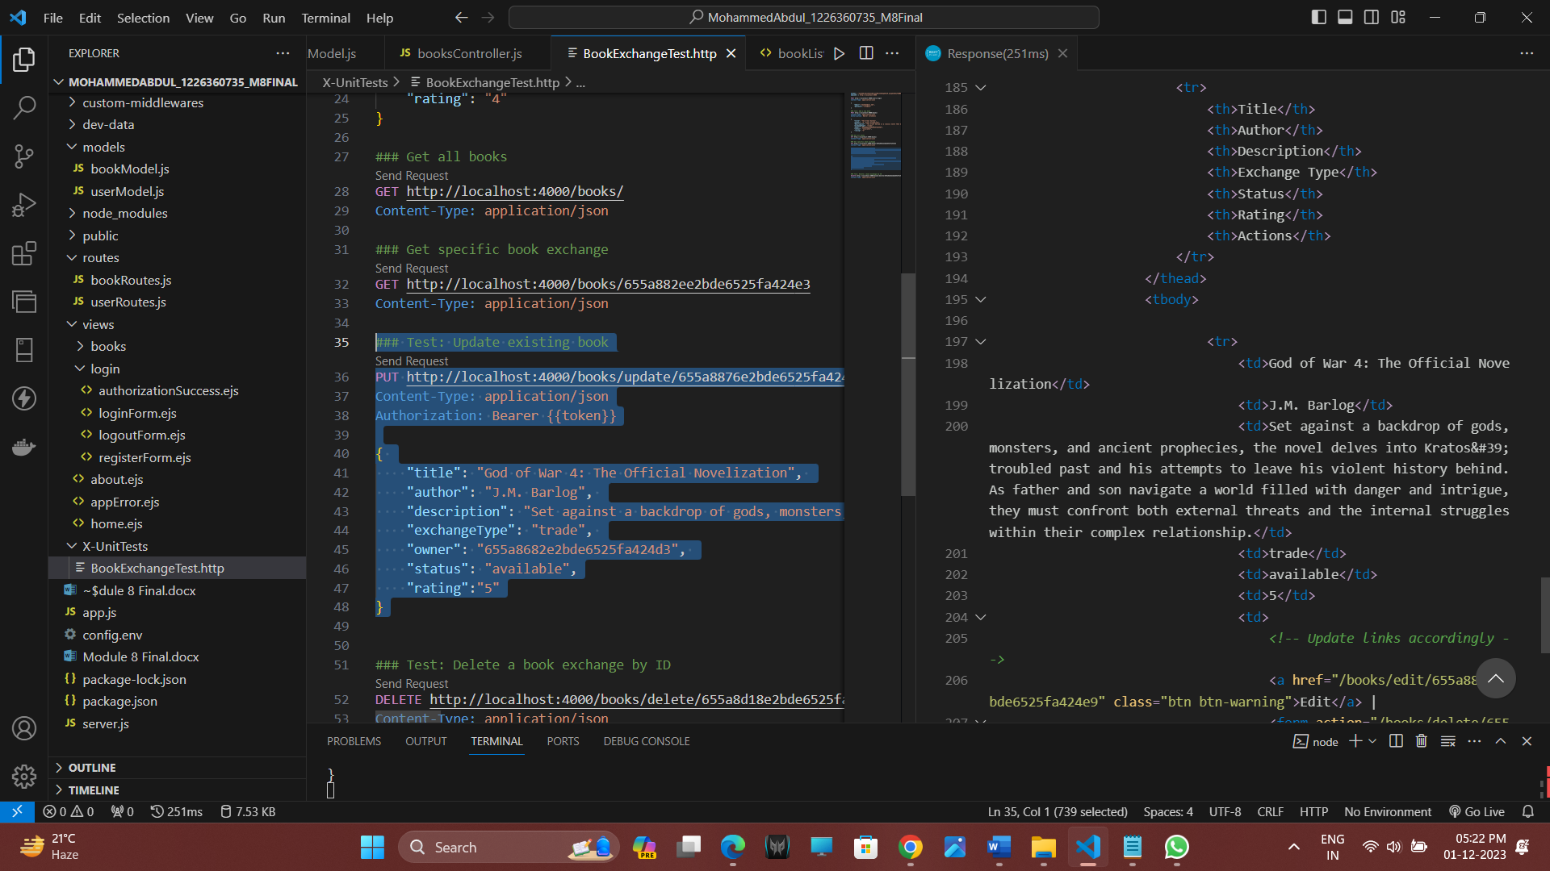

### Test: Delete a book exchange by ID

DELETE http://localhost:4000/books/delete/656a776b315af0881be52c6b

Content-Type: application/json

**Endpoint:** /books/{id} (Deleting a book)

**HTTP Method:** DELETE

**Request:** None

**Response:** Confirmation message

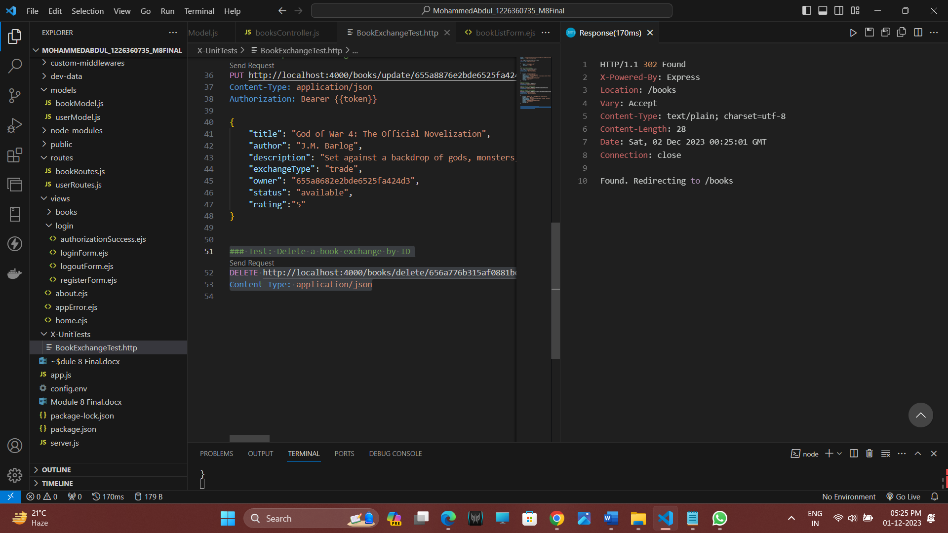

# Screenshots

**Home page**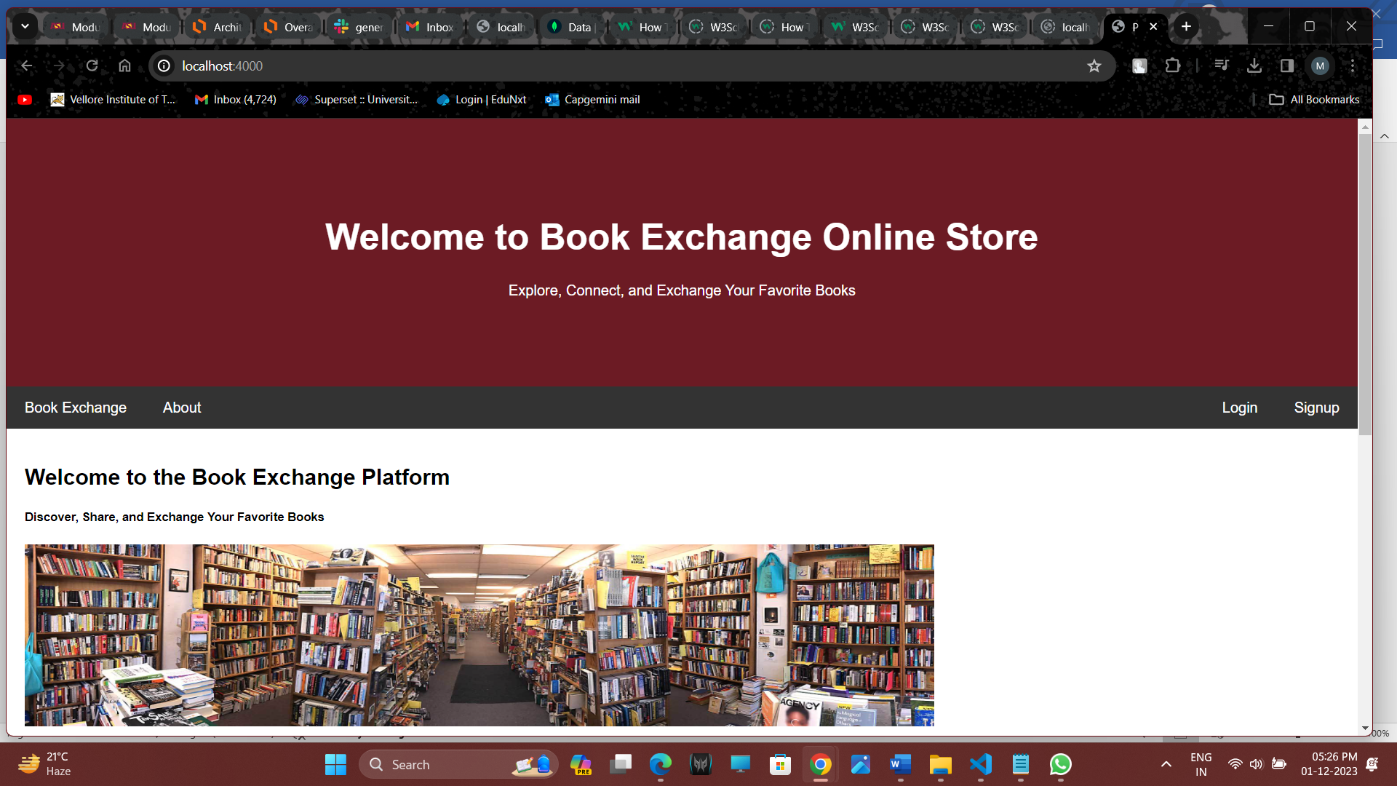

This is home page of the application. I have added buttons into the navbar to make it visually appealing.

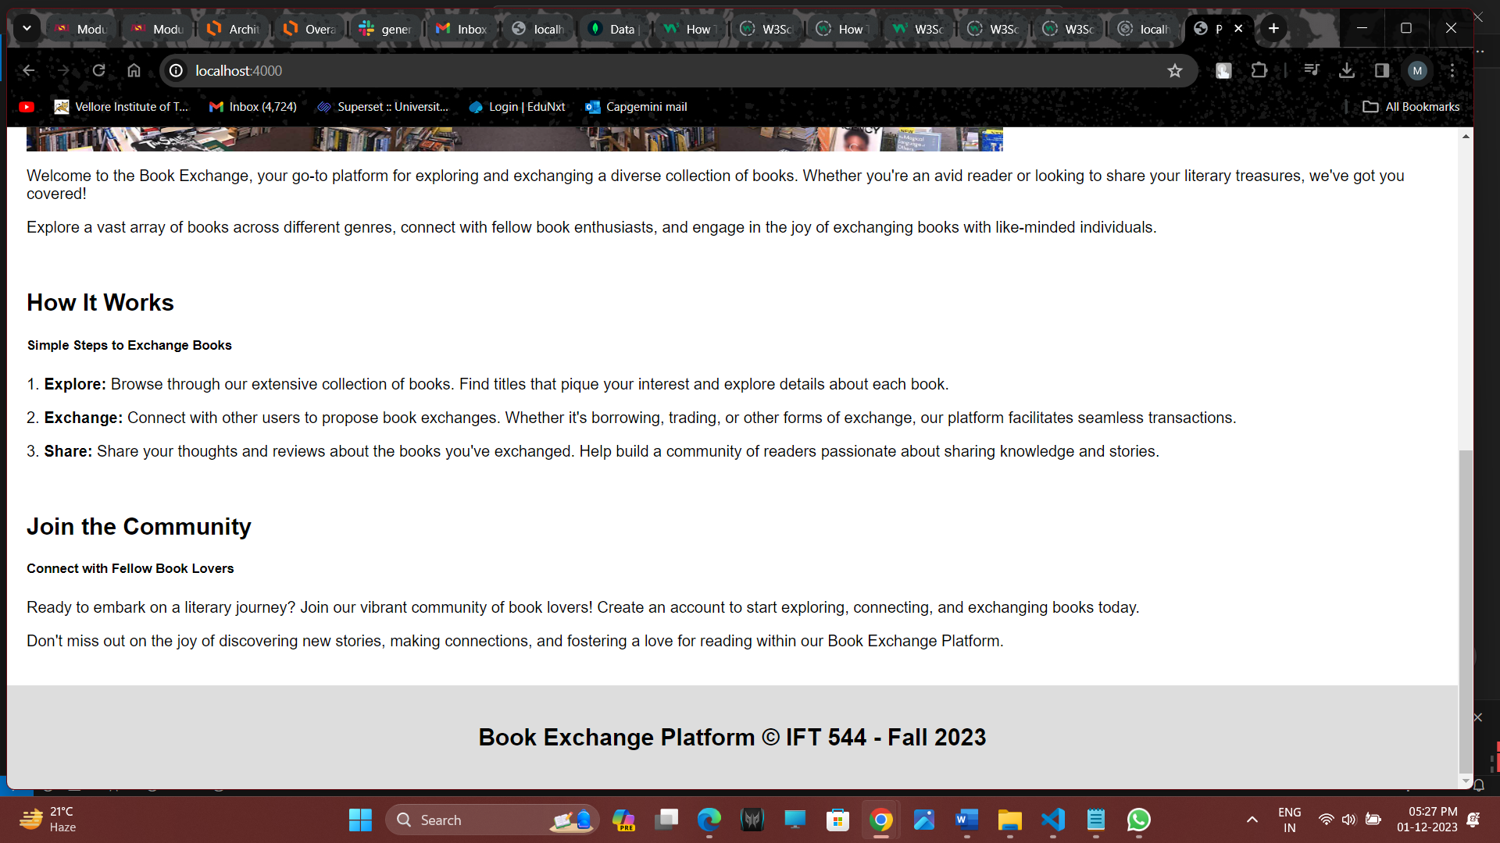

**Login Page**

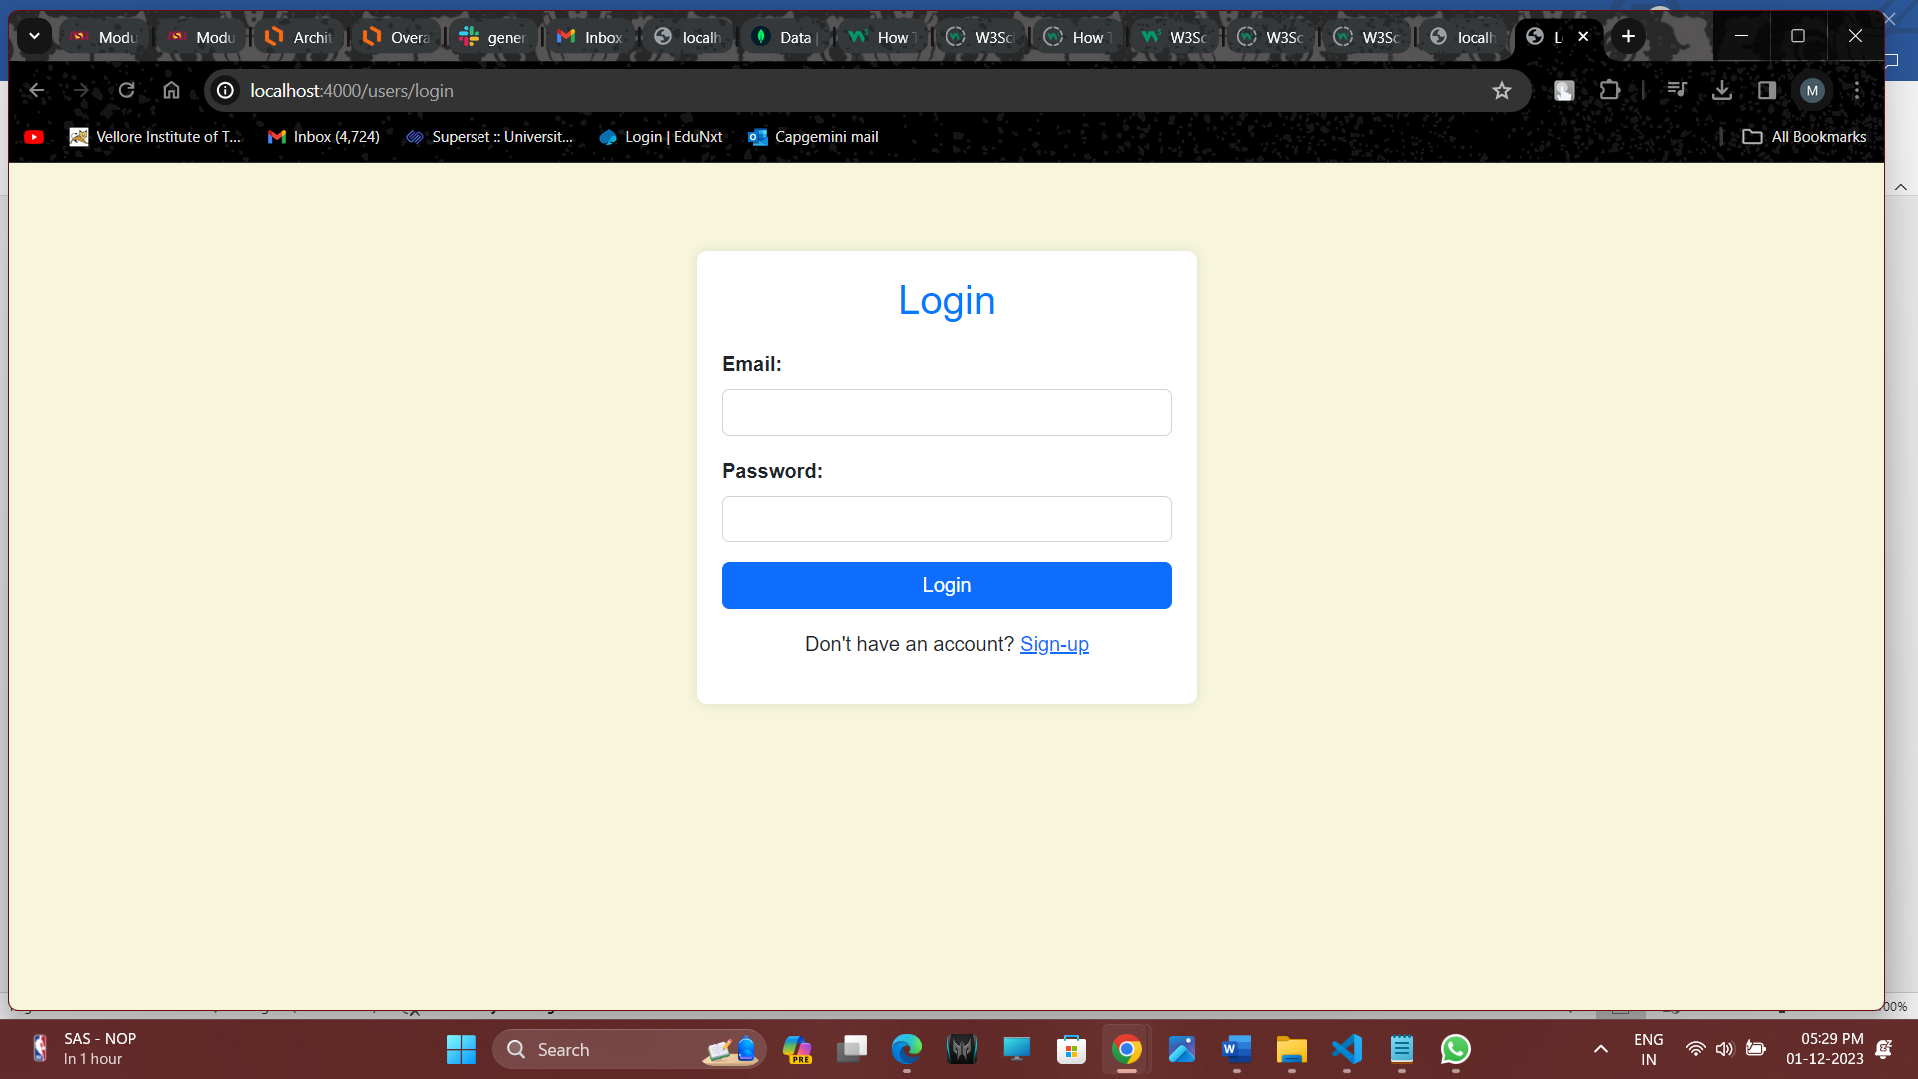 **Entering the login details**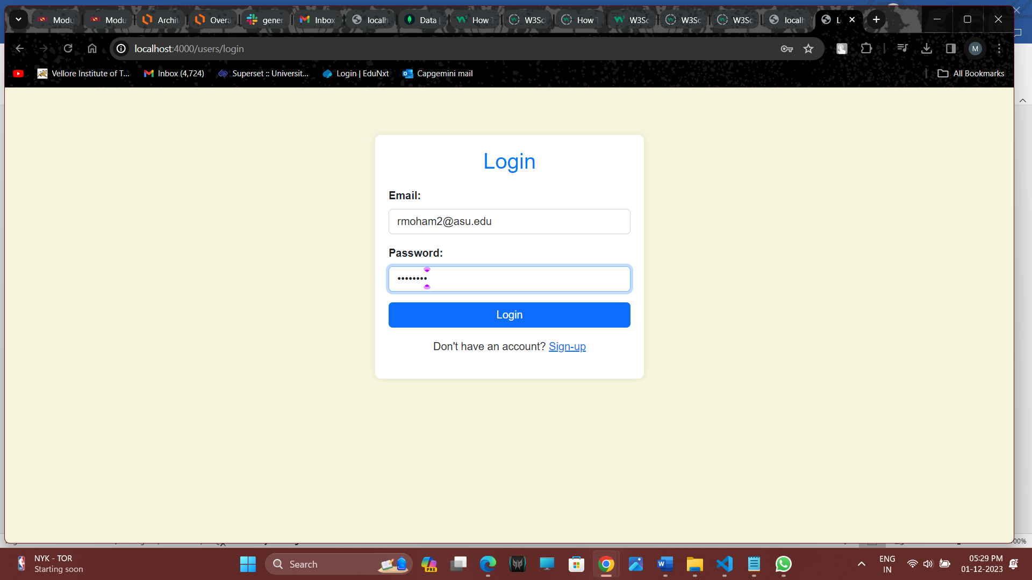

Authorization success and a token is generated.

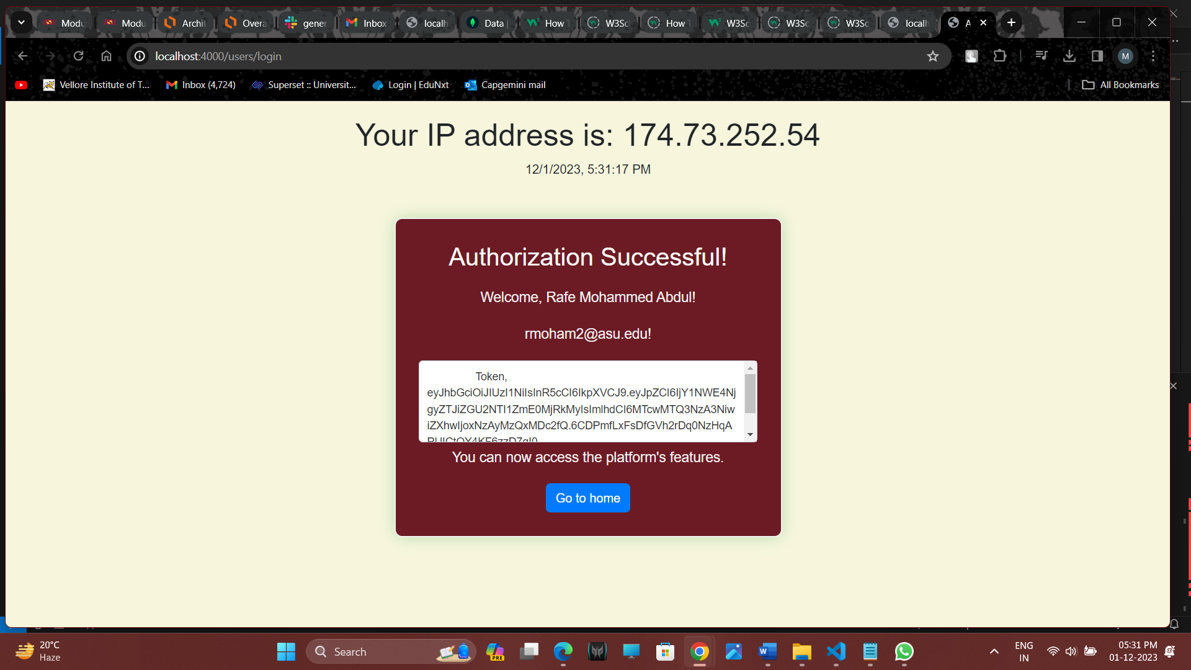

**Signup Page**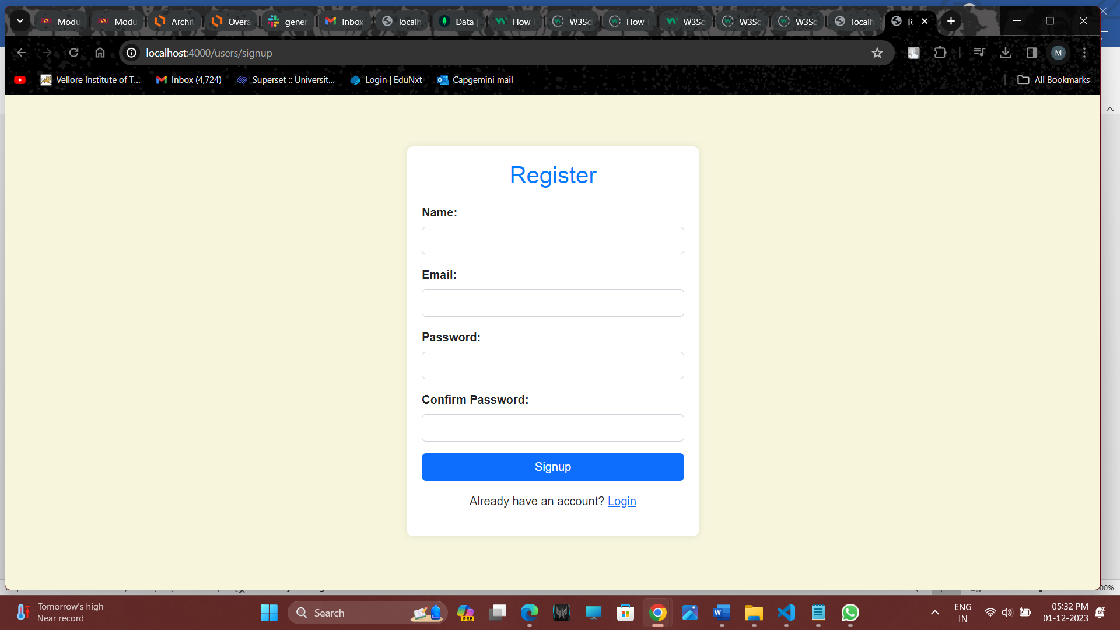

**About page**

I have added an about page.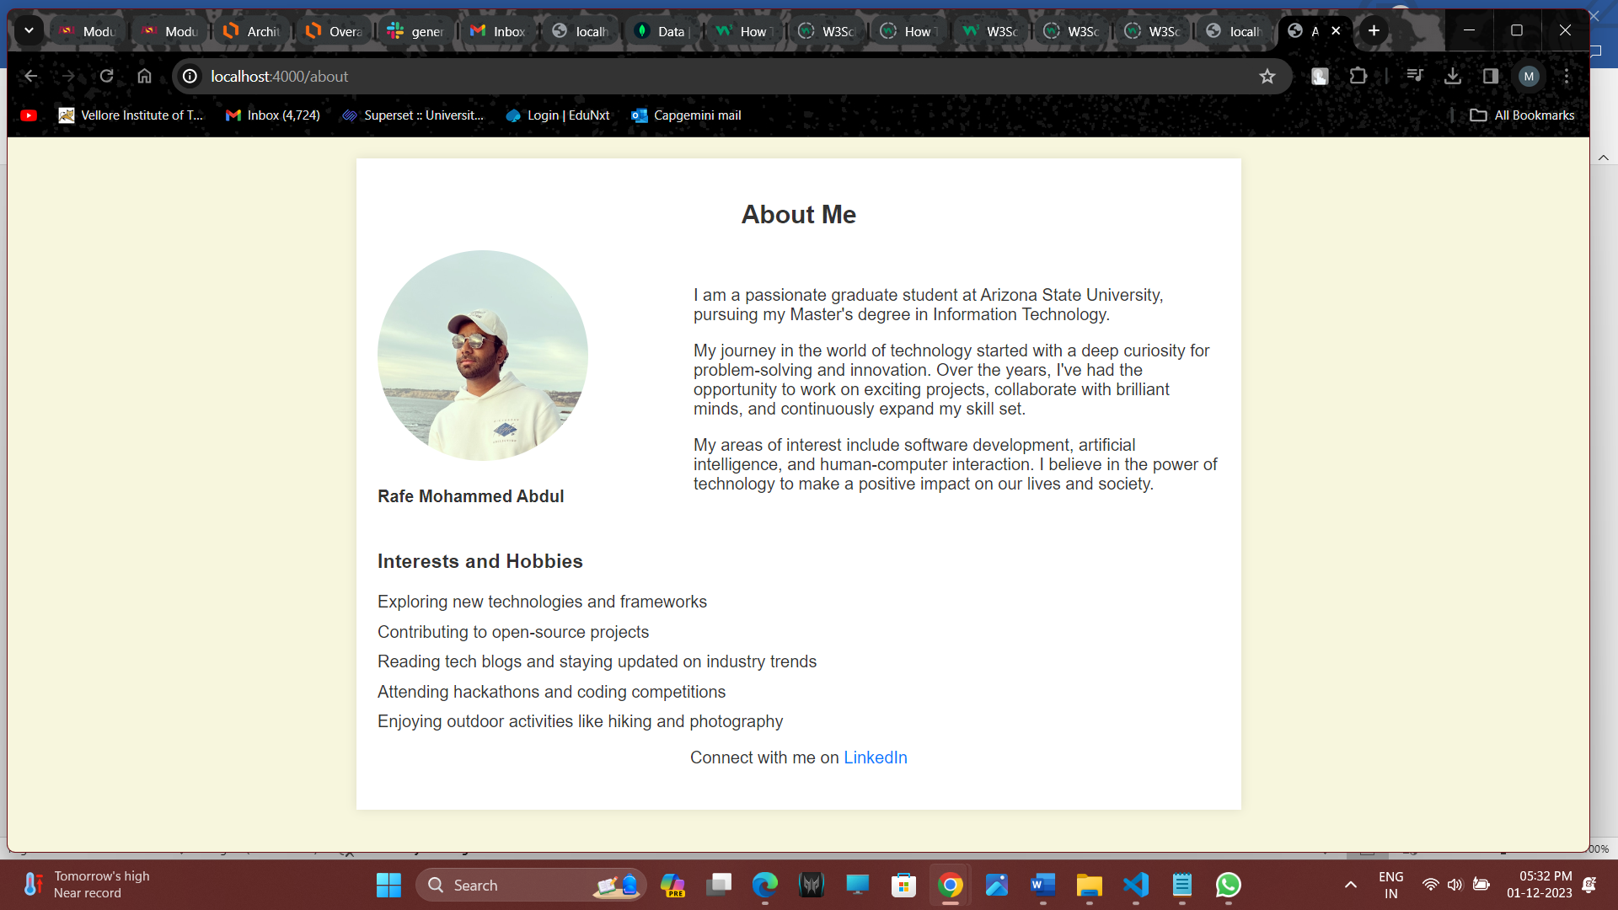

**Book Exchange screen**

I have added the filters feature and also rating a book feature.

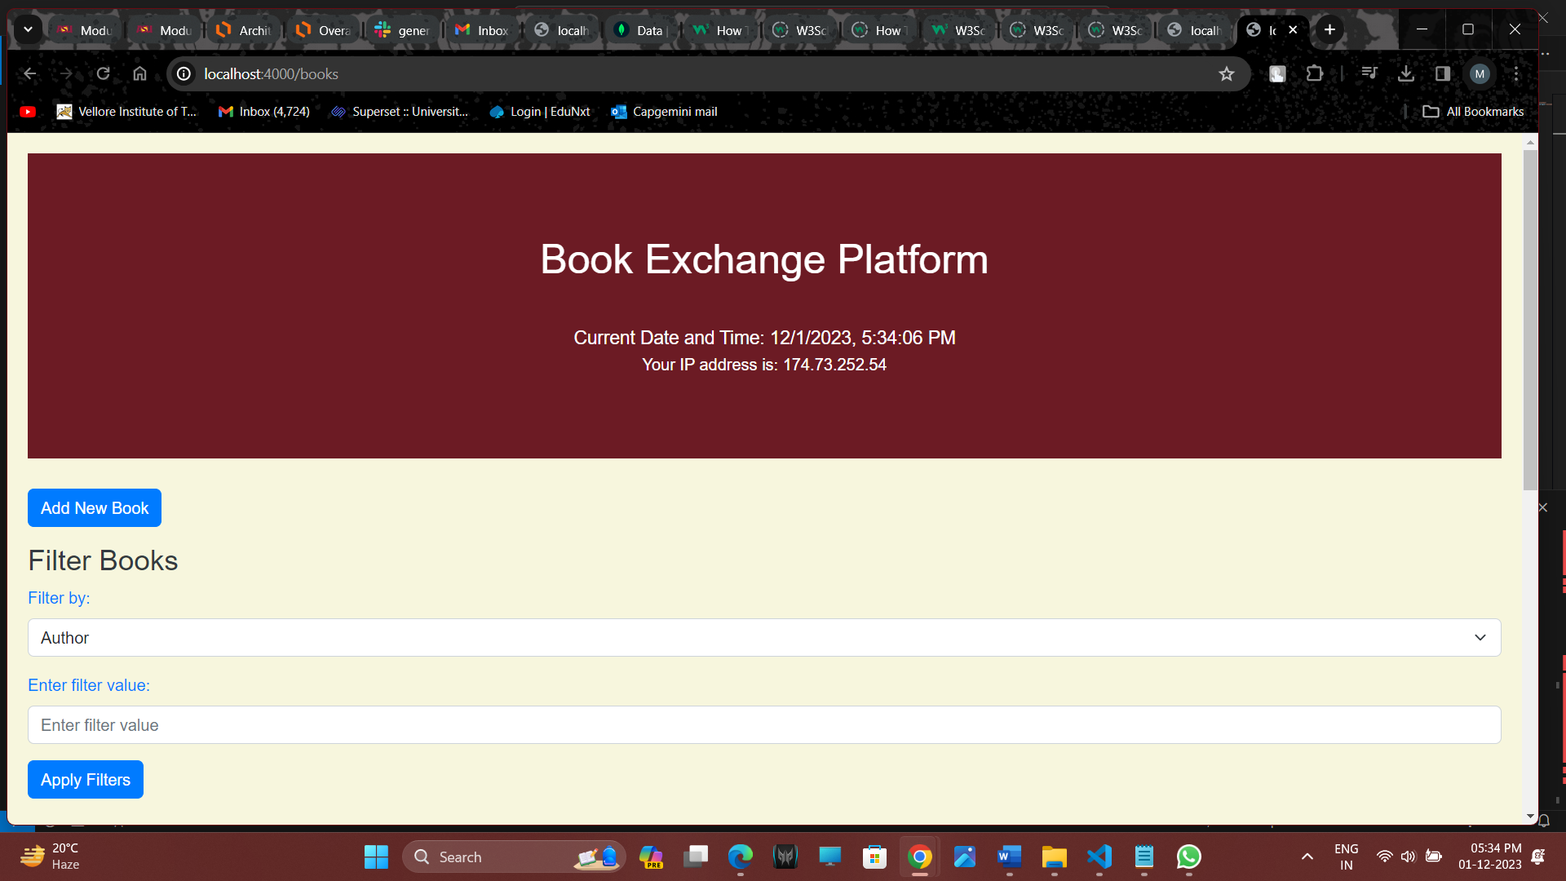

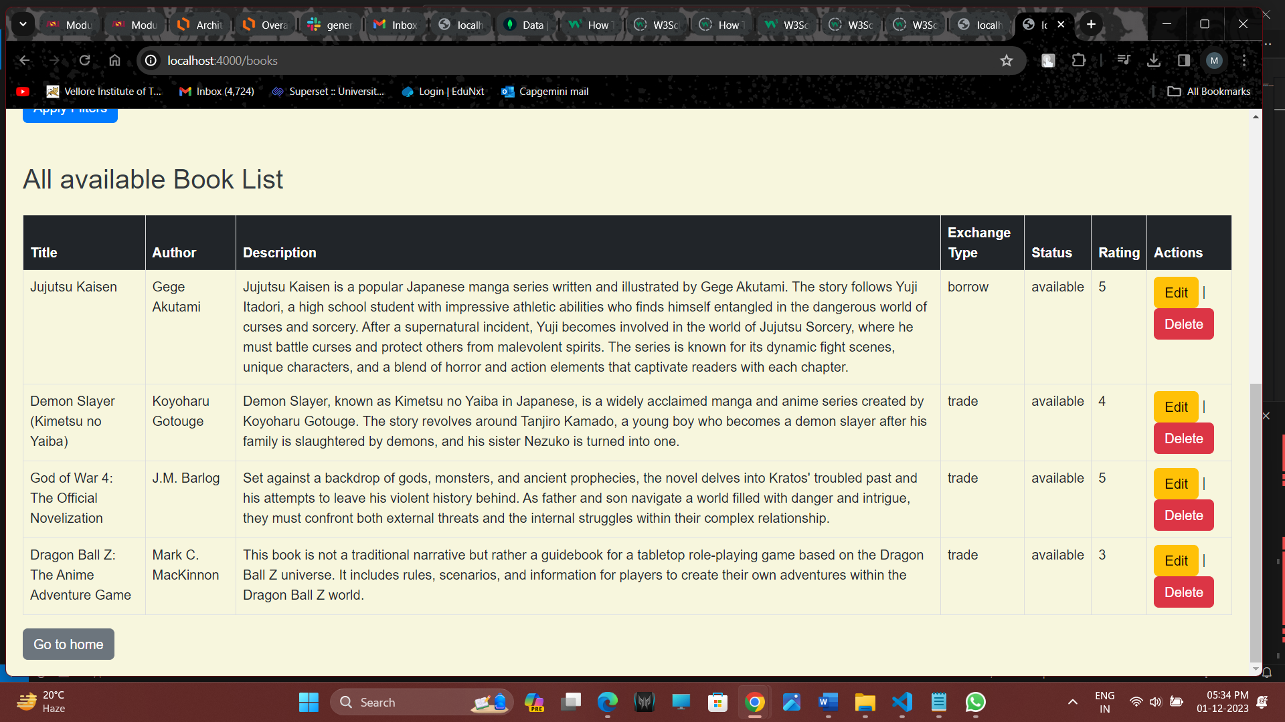

**Filter by Rating**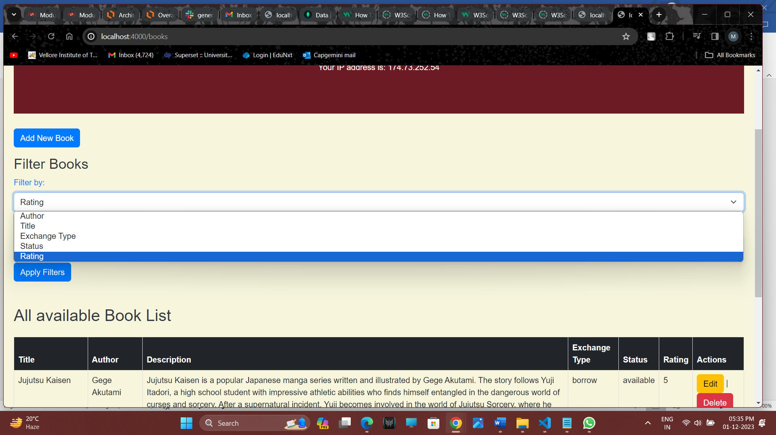

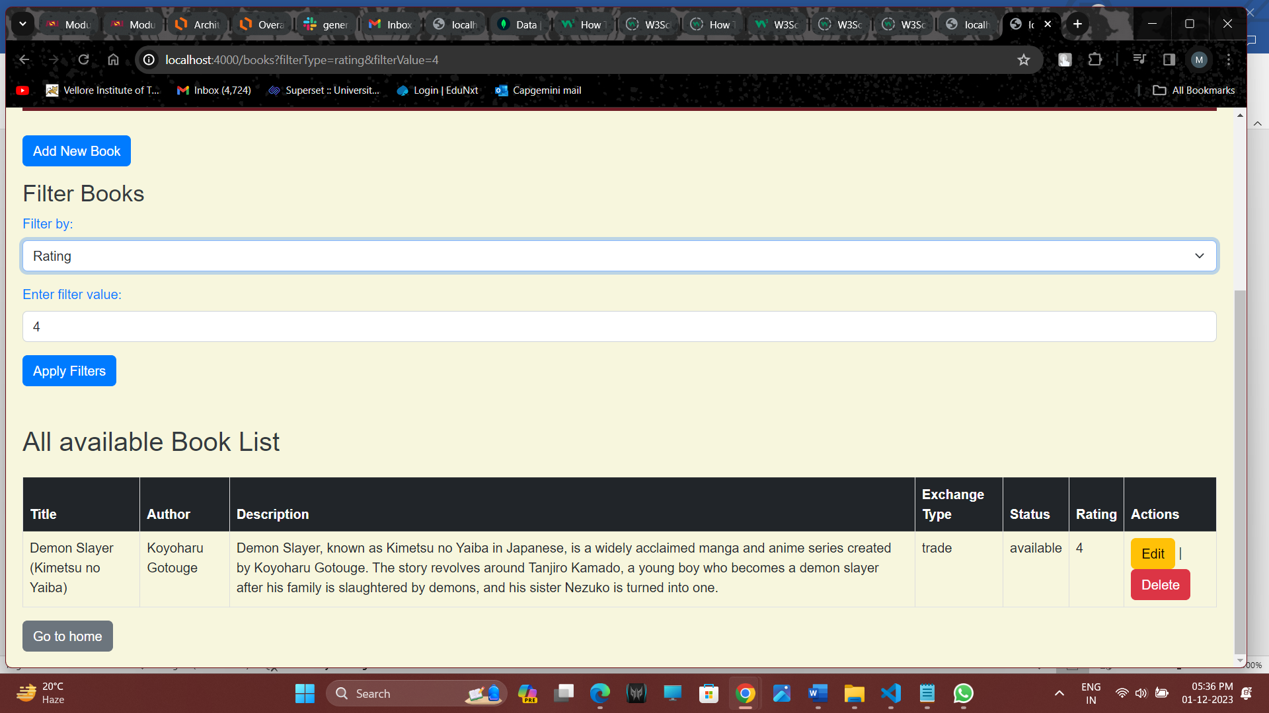

**Add new book**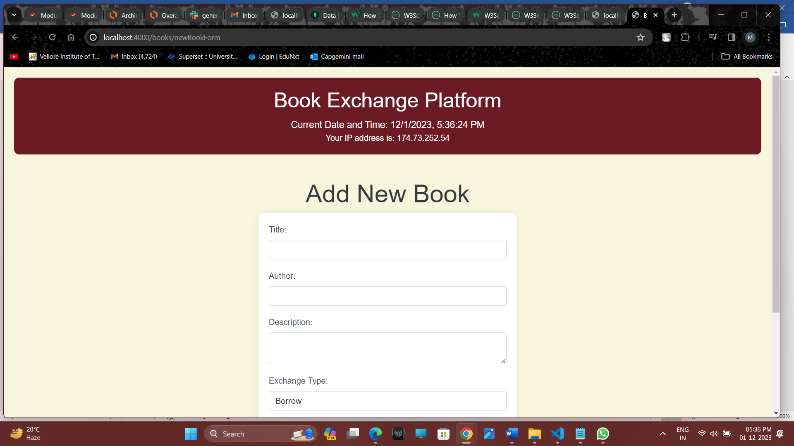

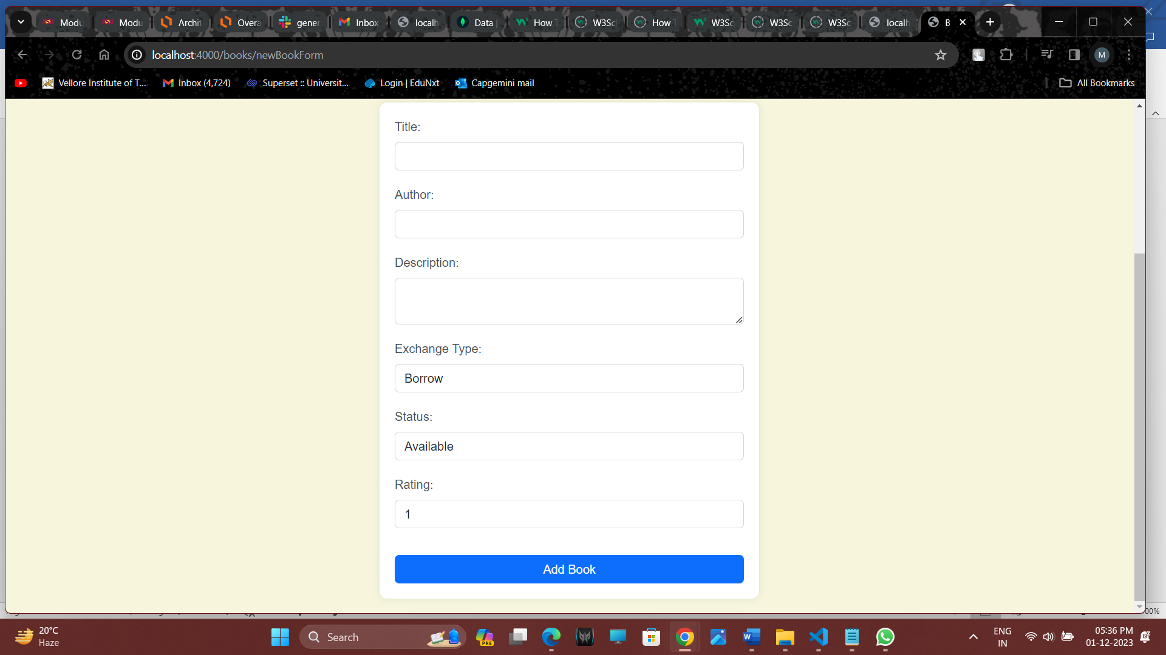

**Edit book**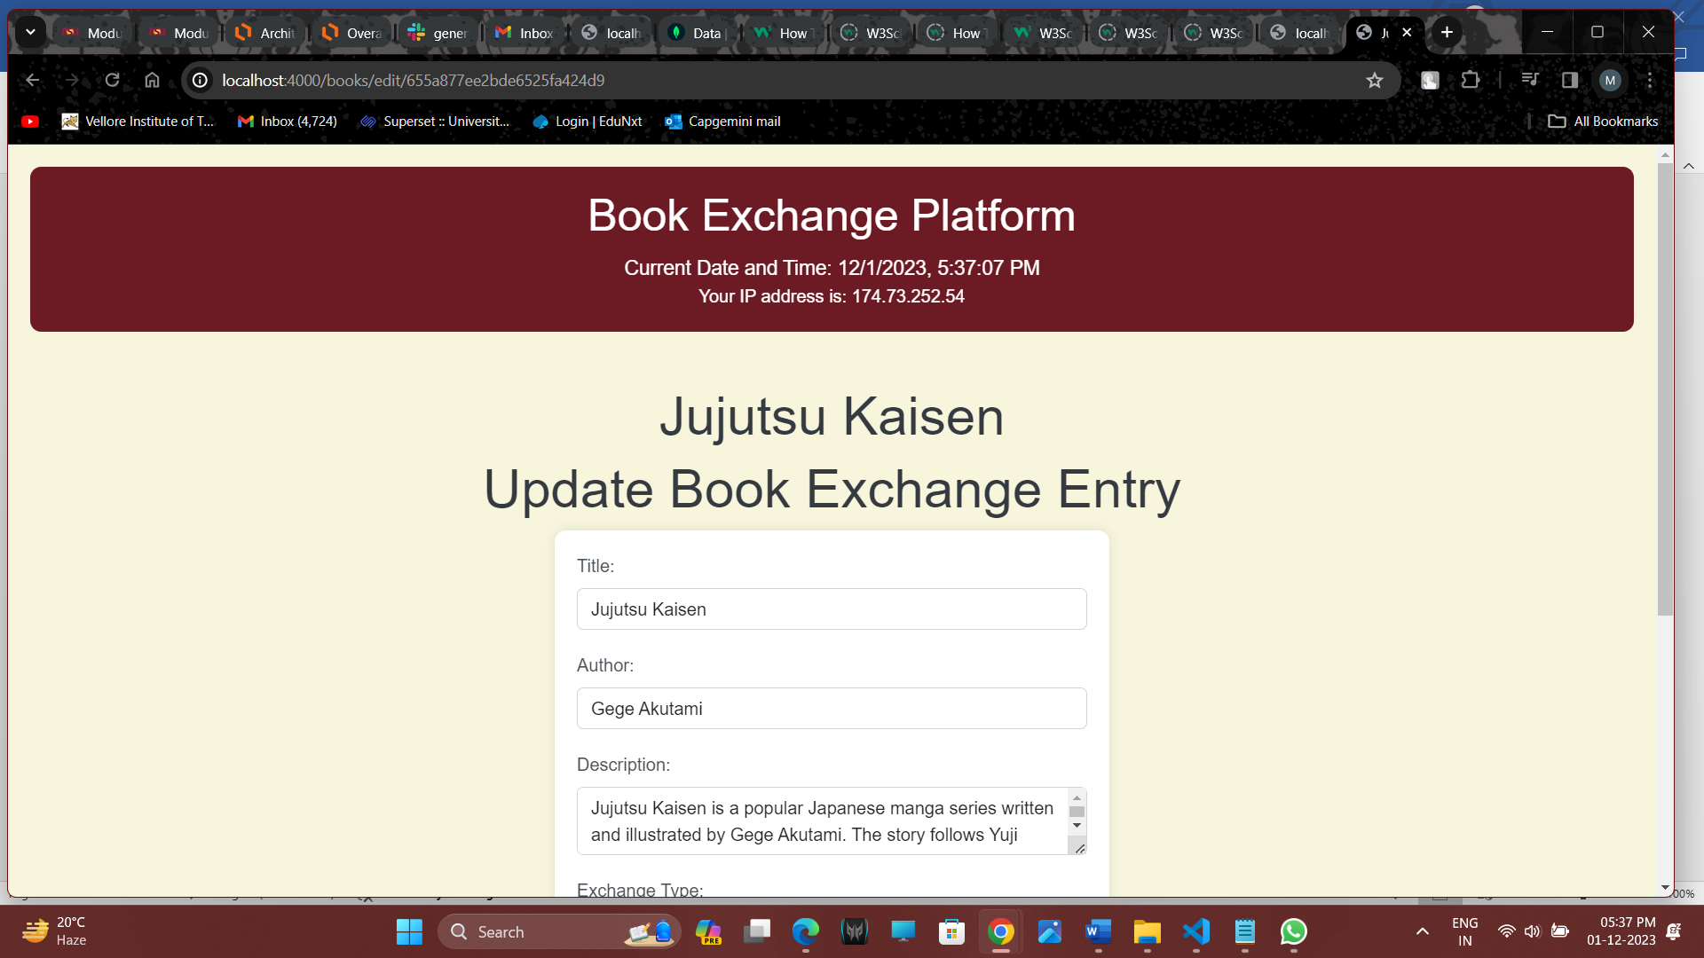

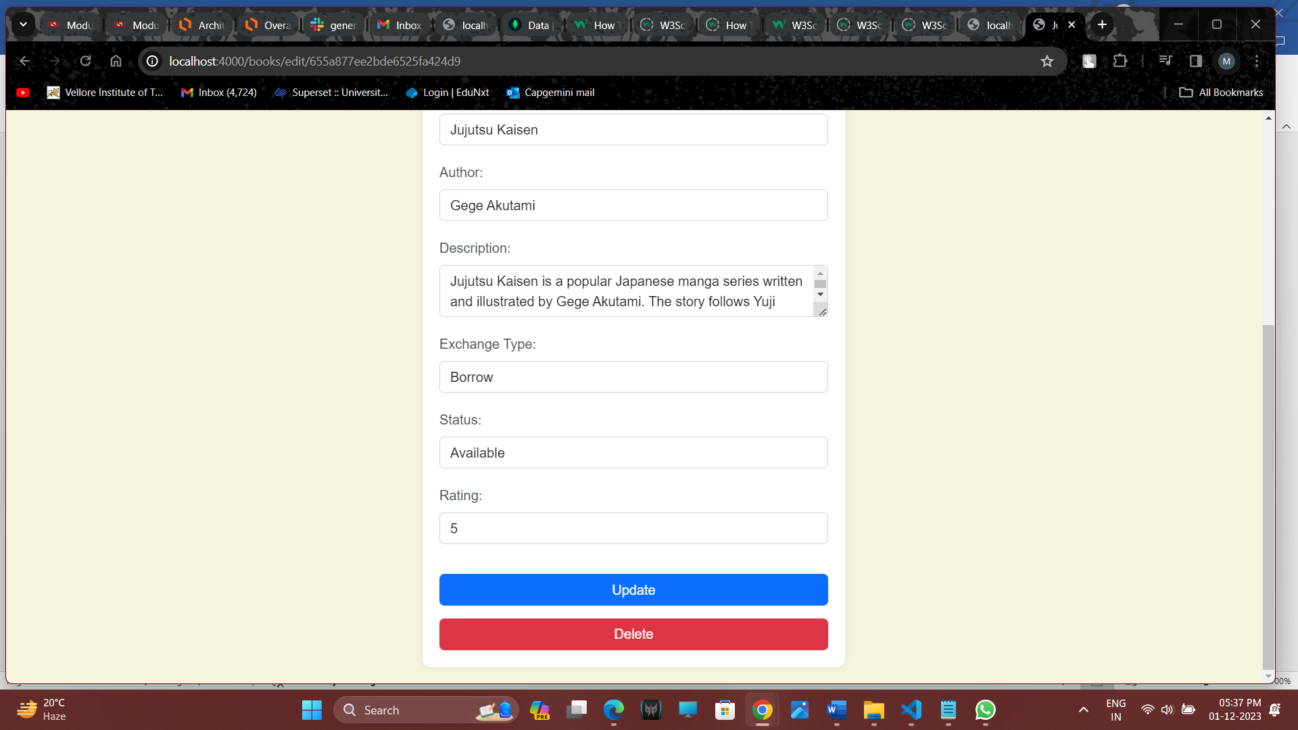Implementation

**Challenges:**

The implementation phase encountered challenges primarily related to authentication complexities and the need for secure data storage. Authentication complexities revolved around verifying and managing user identities securely, especially in a platform where user interactions involve sensitive information like personal details and book exchange history. Ensuring secure data storage posed another challenge, as the platform needed to safeguard user data and book-related information from unauthorized access or data breaches.

**Workarounds and Solutions:**

To address authentication complexities, robust authentication middleware was implemented. This middleware ensures that user identities are securely verified before allowing access to sensitive functionalities. Techniques such as token-based authentication might have been employed, enhancing security by generating and validating tokens for each user session.

For secure data storage, encryption techniques were applied. This involves encoding the stored data in such a way that even if unauthorized access occurs, the information remains unreadable without the appropriate decryption keys. Encryption ensures that user details and book exchange data are stored securely, mitigating the risks associated with data breaches.

**Key Functionalities:**

The platform encompasses key functionalities crucial for an effective book exchange experience:

**User Registration:** A user-friendly registration process was implemented, allowing individuals to sign up securely. This involves the collection of necessary user information while ensuring data privacy and security.

**Book Browsing:** The platform facilitates users in discovering and exploring a diverse collection of books. This involves an intuitive interface for browsing books like filtering based on title, authors, Exchange Type, Status and Rating.

**Secure Book Exchange Mechanisms:** Implementing secure mechanisms for book exchanges is paramount. This includes features like secure communication channels between users, real-time updates on exchange statuses, and secure storage of exchange history. The integration of authentication middleware and encryption techniques ensures the confidentiality and integrity of the book exchange process.

Overall, these solutions and functionalities contribute to a secure, user-friendly, and efficient book exchange platform, enhancing the overall user experience and trust in the system.

Learning Outcomes

**Technical Learning Outcomes:**

**Backend Development Understanding:**

The modules provided a comprehensive understanding of backend development using technologies like Node.js, Express.js, and MongoDB. This involved grasping the principles of server-side scripting, routing, and database management. Practical implementation of these concepts in building a book exchange platform strengthened technical proficiency.

**Authentication Implementation:**

Learning to implement authentication mechanisms was a crucial technical outcome. Dealing with user registration, login sessions, and secure data storage contributed to the acquisition of skills in user identity management. Implementing robust authentication middleware enhanced the security of the platform, a critical aspect in real-world applications.

**Problem-Solving Skills:**

The challenges faced during implementation offered opportunities to develop effective problem-solving skills. Overcoming authentication complexities required analyzing the issues and devising robust solutions. This experience contributes to the ability to approach complex technical problems with a systematic and analytical mindset.

**Non-Technical Learning Outcomes:**

**Project Management:**

The project work involved aspects of project management, including planning, execution, and monitoring. Breaking down the development process into manageable tasks, allocating resources effectively, and adhering to timelines contributed to an understanding of project management principles. This skill is transferable to various contexts where organized planning is essential.

**Effective Problem-Solving:**

While technical problem-solving is a core outcome, the modules also emphasized effective problem-solving in a broader sense. Addressing challenges in user engagement and ensuring a positive user experience required considering various perspectives and making informed decisions. This holistic problem-solving approach is applicable to diverse scenarios beyond technical challenges.

# Constructive Feedback

**Enhance Clarity in Complex Topics:**

While the modules covered a range of technical concepts, there were instances where complex topics could be further clarified. Incorporating additional explanations, examples, or visual aids in areas that proved challenging for learners could enhance overall comprehension. Providing supplementary materials or targeted resources for challenging topics can offer learners multiple perspectives to grasp complex concepts.

**More Hands-On Exercises:**

The inclusion of more hands-on exercises is recommended to reinforce theoretical knowledge. Practical application is a powerful tool for learning, and interactive exercises or coding challenges related to the theoretical content can solidify understanding. These exercises could be designed to simulate real-world scenarios, encouraging learners to apply their knowledge in practical situations. Additionally, providing solutions or walkthroughs for these exercises ensures learners can verify their understanding and learn from the application.

**Interactive Learning Opportunities:**

Introducing interactive elements, such as quizzes, discussion forums, or live coding sessions, can engage learners more actively. These opportunities allow learners to apply what they've learned, ask questions, and collaborate with peers. Interactive sessions also create a more dynamic learning environment, catering to different learning styles and preferences.

**Clear Roadmap and Expectations:**

Providing a clear roadmap and expectations for each module or learning unit can help learners understand the structure of the course. Clearly defined objectives, milestones, and expectations set at the beginning of each section contribute to a sense of direction and purpose, guiding learners through the learning journey.

**Varied Learning Resources:**

Offering a variety of learning resources, including articles, video tutorials, and practical demonstrations, caters to diverse learning preferences. Learners often benefit from different formats, and a mix of resources ensures a more comprehensive learning experience.

Incorporating these suggestions can contribute to an enriched learning experience, accommodating various learning styles and preferences while addressing challenges associated with complex topics.

# References

w3schools, .(2023, December 01). *How TO-Login Form in a Menu*. w3schools.com

<https://www.w3schools.com/howto/howto_css_login_form_navbar.asp>

w3schools, .(2023, December 01). *How TO-Login Form*. w3schools.com

<https://www.w3schools.com/howto/howto_css_login_form.asp>

w3schools, .(2023, December 01). *How TO-Form on image*. w3schools.com

<https://www.w3schools.com/howto/howto_css_form_on_image.asp>

w3schools, .(2023, December 01). *How TO-Filter Elements.* w3schools.com

<https://www.w3schools.com/howto/howto_js_filter_elements.asp>

w3schools, .(2023, December 01). *How TO-Search/Filter Dropdown*. w3schools.com

<https://www.w3schools.com/howto/howto_js_filter_dropdown.asp>

w3schools, .(2023, December 01). *How TO-Top Navigation*. w3schools.com

<https://www.w3schools.com/howto/howto_js_topnav.asp>

CyberWolves,. (2021, June 9). *Node.js API Authentication with JWT (Json Web Token) - Auth Middleware.* Dev Community

<https://dev.to/cyberwolves/node-js-api-authentication-with-jwt-json-web-token-auth-middleware-ggm>

w3schools, .(2023, December 01). *How TO-Sign Up Form*. w3schools.com

<https://www.w3schools.com/howto/howto_css_signup_form.asp>

mdn web docs,. (2023, December 01). *CORS.* Developer.mozilla.org.

<https://developer.mozilla.org/en-US/docs/Glossary/CORS>

Jerry, M. (2023, Feb 8). *Mongo-express-Middleware*. Medium.com

<https://jerrymannel.medium.com/mongo-express-middleware-772de3447867>

# Appendices

**User Guide: Getting Started**

**Prerequisites**

Before you begin, ensure that you have the following installed on your machine:

Node.js: Make sure Node.js is installed. You can download it from nodejs.org.

MongoDB: Install MongoDB and ensure it's running on your machine. You can download it from mongodb.com.

**Install Dependencies***npm install*

**Run the application**

*Node server.js*

**Access the Application:**

Open your web browser and go to http://localhost:3000.

**Authentication**

* **Login or Signup:**
  + If you have an account, login with your credentials.
  + If not, signup to create a new account.
* **Explore and Exchange Books:**
  + Navigate to the "Book Exchange" section to explore available books.
  + Propose exchanges or add your books to the platform.

**Customer-Middleware**

Authenticate and authorize token.

const jwt = require('jsonwebtoken');

const User = require('../models/userModel');

// Middleware for authenticating users

const authenticate = async (req, res, next) => {

    try {

        // Retrieve the JWT token from cookies

        const token = req.cookies.jwt;

        // Verify the token using the JWT_SECRET

        const decodedToken = jwt.verify(token, process.env.JWT_SECRET);

        // Extract user ID from the decoded token

        const userId = decodedToken.id || decodedToken._id;

        // Find the authenticated user in the database

        const authenticatedUser = await User.findById(userId);

        if (!authenticatedUser) {

            // Redirect to the login page if the user is not found

            res.render(`./login/loginForm`, { title: " You are redirected as you are not Authenticated", user: undefined });

        } else {

            // Set the authenticated user in the request object

            req.user = authenticatedUser;

            next();

        }

    } catch {

        // Redirect to the login page if there's an error in authentication

        res.render(`./login/loginForm`, { title: " You are redirected as you are not Authenticated", user: undefined });

    }

};

// Middleware for authorization based on user roles

const authorize = async (req, res, next) => {

    const currentUser = req.user;

    const userRole = currentUser.role;

    if (userRole) {

        // User is authorized, proceed to the next middleware or route handler

        next();

    } else {

        // User is forbidden from accessing the resource

        res.status(403).json({ message: 'Forbidden' });

    }

};

// Function to fetch a user by ID

async function fetchUserById(userId) {

    try {

        const user = await User.findById(userId);

        if (user) {

            console.log('Found user:', user);

        } else {

            console.log('No user found with the provided ID.');

        }

    } catch (error) {

        console.error('Error fetching user:', error);

    }

}

// Export the authentication and authorization middleware

module.exports = { authenticate, authorize };

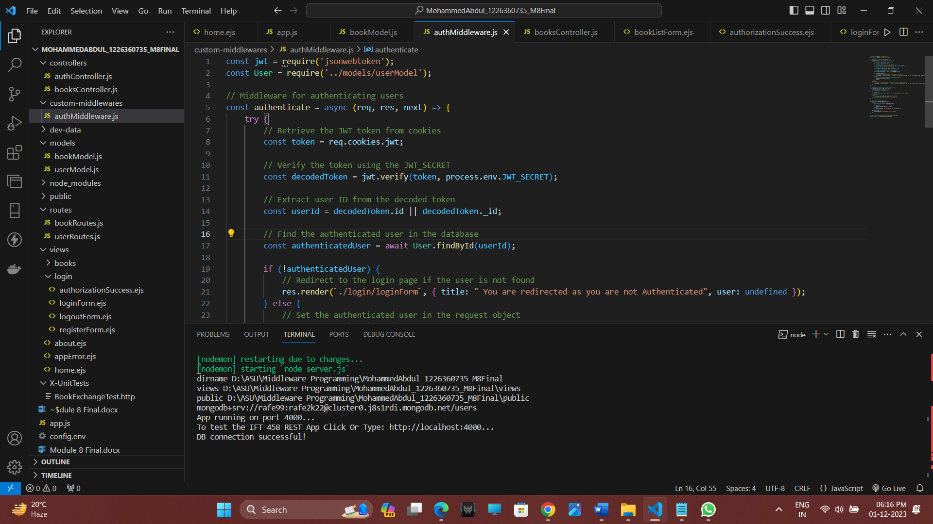

**authenticate Middleware:**

* Validates the JWT token present in the cookies.
* Verifies the token's signature using the JWT_SECRET.
* Finds the user in the database based on the extracted user ID.
* If the user is authenticated, sets the user in the request object (req.user) and proceeds to the next middleware or route handler.
* If authentication fails or the user is not found, redirects to the login page.

**authorize Middleware:**

* Checks the role of the authenticated user.
* If the user has a role, proceeds to the next middleware or route handler (indicating authorization).
* If the user doesn't have a role, responds with a 403 Forbidden status.

**fetchUserById Function:**

* A utility function to fetch a user by ID from the database.

**Sequence Diagram for authentication**

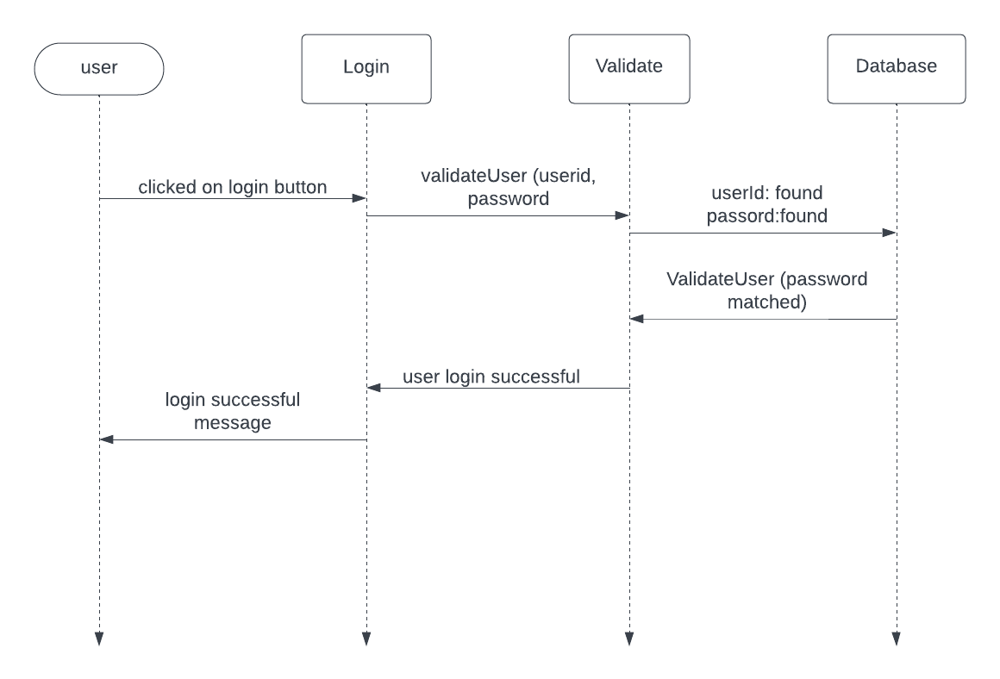

**Sequence diagram for Authorization**

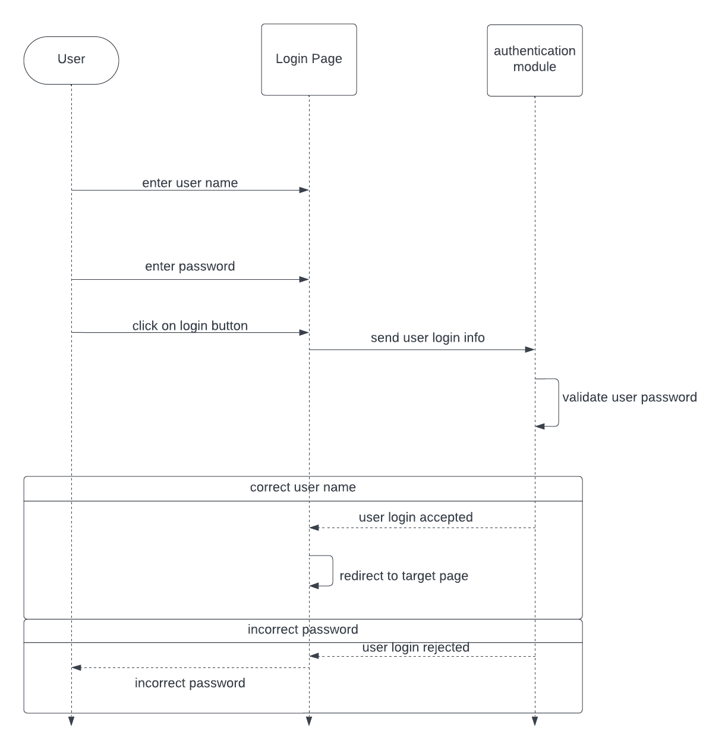

**Mongoose Schema for book exchange model**const mongoose = require('mongoose');

// Define a Mongoose schema for the Book Exchange model

const bookExchangeSchema = new mongoose.Schema({

    title: {

        type: String,

        required: true

    },

    author: {

        type: String,

        required: true

    },

    description: {

        type: String,

        required: true

    },

    exchangeType: {

        type: String,

        enum: ['borrow', 'trade'], // Specifies allowed values for exchangeType

        required: true

    },

    owner: {

        type: mongoose.Schema.Types.ObjectId,

        ref: 'User', // References the 'User' model for the owner field

        required: true

    },

    status: {

        type: String,

        enum: ['available', 'unavailable'], // Specifies allowed values for status

        default: 'available' // Sets a default value if not provided

    },

    rating: {

        type: Number,

        min: 1,

        max: 5,

        default: 1 // Sets a default rating if not provided

    },

}, { timestamps: true }); // Adds createdAt and updatedAt timestamps to the documents

// Create a Mongoose model named 'BookExchange' using the defined schema

const BookExchange = mongoose.model('BookExchange', bookExchangeSchema);

// Export the BookExchange model for use in other parts of the application

module.exports = BookExchange;

* **title, author, description, exchangeType:** These fields define the basic information about a book, including its title, author, description, and the type of exchange (borrow or trade).
* **owner:** This field represents the owner of the book and is linked to the 'User' model using the user's ObjectId.
* **status:** Indicates whether the book is available or unavailable. It uses the enum constraint to specify allowed values.
* **rating:** Represents the rating of the book, constrained to a range between 1 and 5. It has a default value of 1.
* **timestamps:** The timestamps option automatically adds createdAt and updatedAt fields to the documents, providing information about when the document was created and last updated.
* **BookExchange:** The BookExchange model is created using the defined schema and can be used to interact with the MongoDB collection for book exchanges.